John Vos

Documentation of the process of building our VR escape room, such as; challenges, research, development, build levels, work done by which member.

Integrated group project in computing

Documentation

Table of Contents

Project Plan & Specifications: 3

Game Concept: 3

Teaching Concepts: 3

Final Code to Unlock Door: 3

Testing: 3

Group Meeting: 3

Software being used: 3

Research: 4

Room Design: 4

Coding: 4

Puzzles: 4

Room Design: 0

Room 1: 0

Room 2: 0

Room 3: 0

Room 4: 0

Escape Pod: 0

Tutorial Room: 1

Time Frame: 0

Project Plan timeline: 0

Reason for set date: 0

Contingency Plan: 1

Challenges: 2

Ross 2

Challenges encountered: 2

Jack: 2

Challenges encountered: 2

James: 2

Challenges encountered: 2

John: 2

Challenges encountered: 2

Evidence / Screenshots of Progress: 3

Team Roles: 4

Ross 4

Reason for role: 4

Jack: 4

Reason for role: 4

James: 4

Reason for role: 4

John: 4

Reason for role: 4

References: 5

# Project Plan & Specifications:

## Game Concept:

The game will be a VR escape room aimed at KS3 (11 to 14 year olds) students studying computer science using unity (version 2018.3.6) for windows on the Vive VR set.

The player will have 1 hour to complete 4 puzzles to then create a piece of code that will unlock the door to the escape pod. Furthermore, they will have 8 minutes per room and if there is no progress within 3 minutes they will be given a hint to help to solve the problem.

We chose 1 hour as the game is in VR more than an hour in the headset can be too much and disorientate the player, research has also found that 2 hours is the absolute max. In addition, we chose 8 minutes per room as this will give the player enough time to then solve the final puzzle to get into the escape pod. The rooms can be done in any order though we will advise the user to complete them in order, each room will have a number above the door to indicate the order.

## Teaching Concepts:

We will be using scratch code blocks to teach key concepts of computer science coding.

## Lesson plan:

## Final Code to Unlock Door:

## Testing:

We will test the game ourselves as we develop each room, James’s cousin will also test the game as he is the target audience.

## Group Meeting:

We chose Wednesday as the due date for most of our deliverables as this is when we are always able to meet up every week. Furthermore, we will also communicate on other days to come in and work together via discord

## Software being used:

* Unity version 2018.3.6 to develop the game.
* Vive VR as the platform on which it will be played.
* Discord server to communicate on dates we come in and progress.
* Github to track progress.

## UseCases

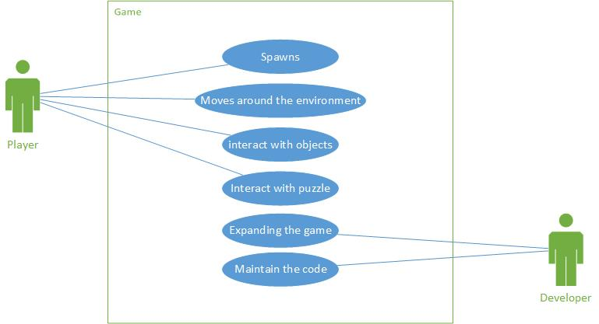

Don’t need developer, add teacher or some admin function

# Research:

Room Design:

Coding:

<http://scratched.gse.harvard.edu/sites/default/files/scratchprogrammingconcepts-v14.pdf>

## Puzzles:

**Black light;**

Difficulty 1) have the player turn on the black light to reveal a hidden code or pattern.

Difficulty 2) have the player search for a cable to attach to the black light then to the plug, to reveal the hidden code or pattern.

Code Difficulty 1) have the code display a 4 digit number for the lock, e.g. 1234.

Code Difficulty 2) have a code disguised as a pattern of lines representing the digits.

Code Difficulty 3) have a full wall covered in symbols and numbers, e.g. certain colour code.

Pattern Difficulty 1) pattern is displayed when the light comes on, e.g. a rectangle.

Pattern Difficulty 2) have the pattern hidden in scrambled lines, solution is a particular colour.

**Hidden items;**

Difficulty 1) have key cards or playing cards with numbers on them hidden for the player to find, colour will indicate the order, colour will be shown on keypad, e.g. green box around first digit.

Difficulty 2)

Hiding places) in boxes / under carpet / coat / inside a book / draw / behind a plug.

**Maze:**

Difficulty 1) have the player drag a pin along a maze into the hole.

Difficulty 2) player has a time limit to solve the maze.

Difficulty 3) the maze will move as the player moves the pin along the hole.

**Puzzle solutions:**

Hidden code = safe / phone / computer / padlock.

Hidden pattern = phone / tablet.

## Clue:

Glow in the dark clue.

Morse code.

Pressure plate.

# Room Design:

## Room 1:

## Room 2:

## Room 3:

## Room 4:

## Escape Pod:

## Tutorial Room:

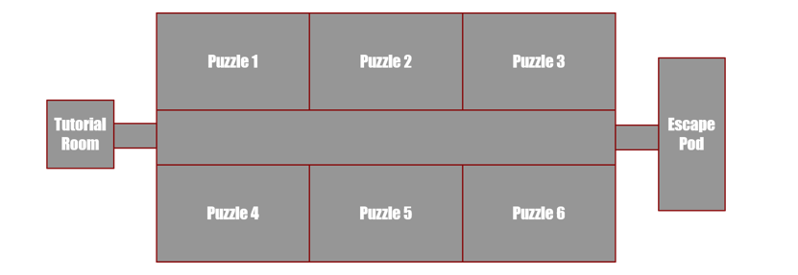

# Time Frame:

## Project Plan timeline:

|  |  |  |
| --- | --- | --- |
| **Goal** | **Deadline Date** | **Person Responsible for development** |
| Puzzle room 1 research | 13th March | John & Ross |
| Room 1 layout & textures | 13th March | Jack & James |
| Room 1 puzzle implemented | 20th March | John & James |
| Testing Room 1 | 21st March | Everyone |
| Puzzle room 2 research |  |  |
| Room 2 layout & textures |  |  |
| Room 2 puzzle implemented |  |  |
| Testing Room 2 |  |  |
| Puzzle room 3 research |  |  |
| Room 3layout & textures |  |  |
| Room 3 puzzle implemented |  |  |
| Testing Room 3 |  |  |
| Puzzle room 4 research |  |  |
| Room 4 layout & textures |  |  |
| Room 4 puzzle implemented |  |  |
| Testing Room 4 |  |  |
| Tutorial layout & textures |  |  |
| Tutorial room testing |  |  |

## Reason for set date:

# Contingency Plan:

We are starting by making room 1 for VR, as none of us have any previous experience with Unity we are going to start with the first puzzle room to give an idea of the challenges and difficulty we are going to face during the development of this project. Furthermore, if this proves too much of a challenge for the time frame we have set and to be able to deliver a working VR escape room. Moreover, if the VR does prove to be too much of a challenge we are planning on falling back on simply making it a 2D escape room rather than 3D.

# Challenges:

Ross:

### Challenges encountered:

## Jack:

### Challenges encountered:

none

## James:

### Challenges encountered:

## John:

### Challenges encountered:

# Evidence / Screenshots of Progress:

# 

# Team Roles:

Ross:

3D assets & Room Design: Responsible for creating 3D assets on Blender and assisting in designing the visual look of the game.

## Reason for role:

## Jack:

Programmer & sound effects: Responsible for helping with programming and developing sound effects

### Reason for role:

## James:

Programmer; Responsible for creating 3D assets on Blender and assisting in designing the visual look of the game.

### Reason for role:

## John:

Admin & room design: Responsible for writing documentation and designing the visual look of the game

### Reason for role:

# References:

**Assignment brief:**

<https://studentcentral.brighton.ac.uk/webapps/blackboard/execute/content/blankPage?cmd=view&content_id=_3335048_1&course_id=_110301_1>

**Puzzle ideas:**

<https://escaperoomtips.com/design/escape-room-puzzle-ideas>

<http://www.queencityescape.com/top-20-puzzle-ideas/>